**Project 4**

**AIM :** The Aim of the project is to create a web applications , with minimum 3 or 4 menu . which includes includes the HTML, CSS, Bootstrap and JavaScript , also which include javascript validations.

**Code**

Github link –

**WEBSITE FLOW**

**CODE**

**LANDING PAGE**

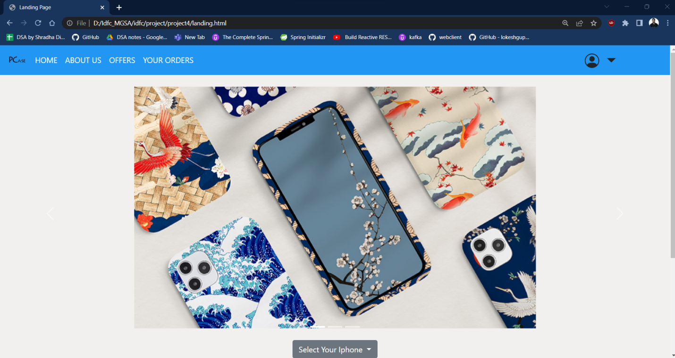

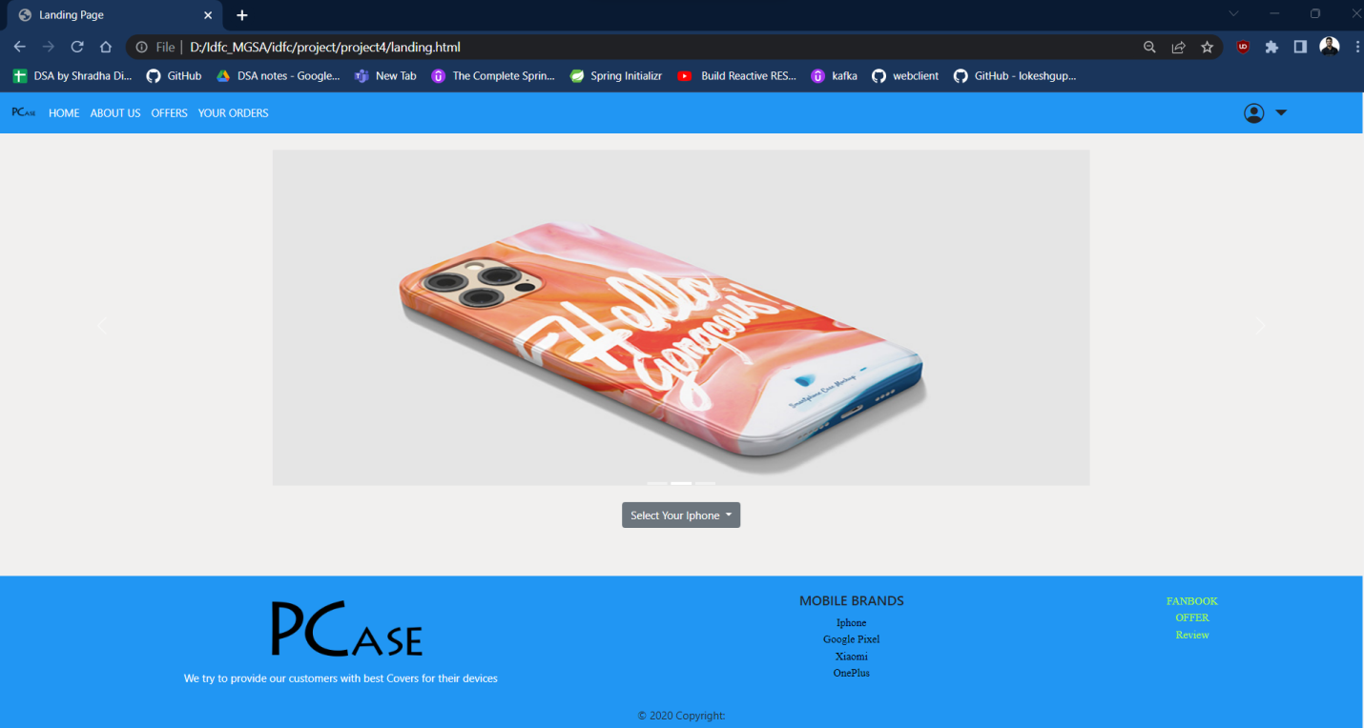

**Selecting Phone Model**

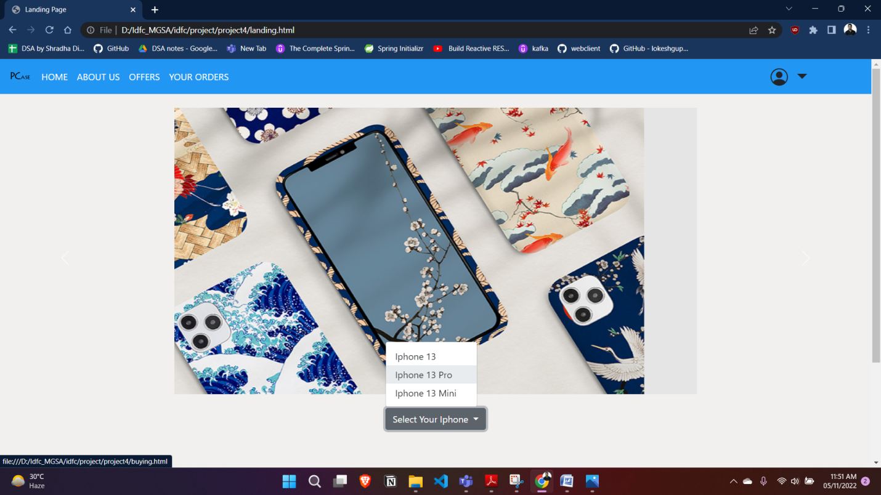

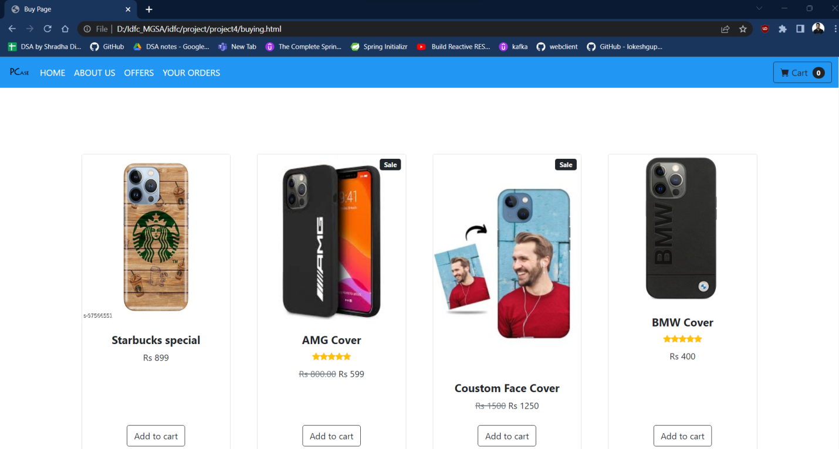

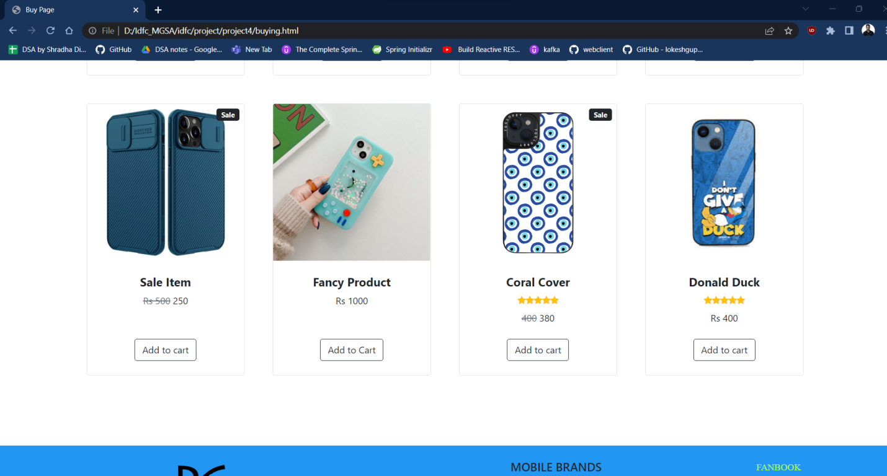

**Add to Cart**

**Selecting 1st 2nd and 3rd mobile covers**

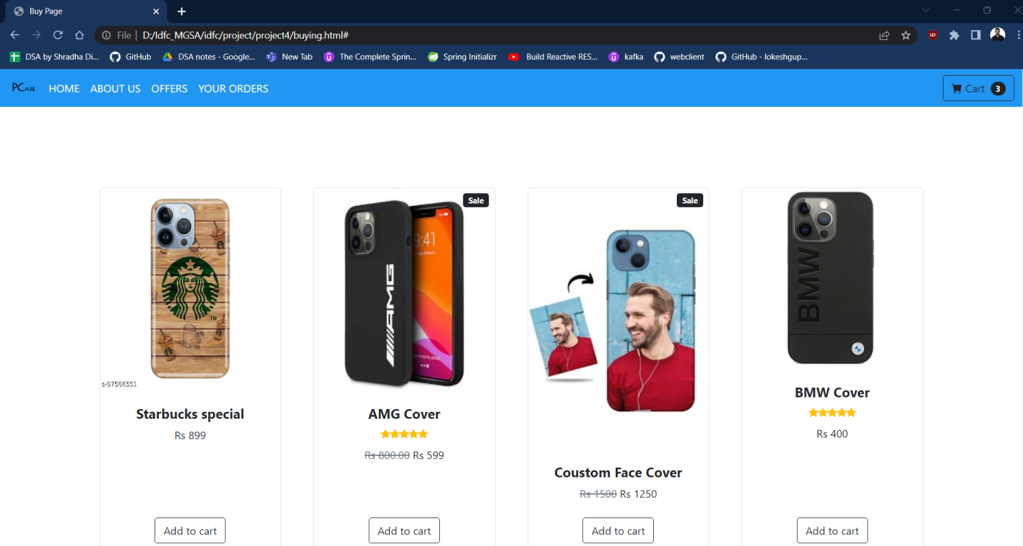

**Clicking on cart**

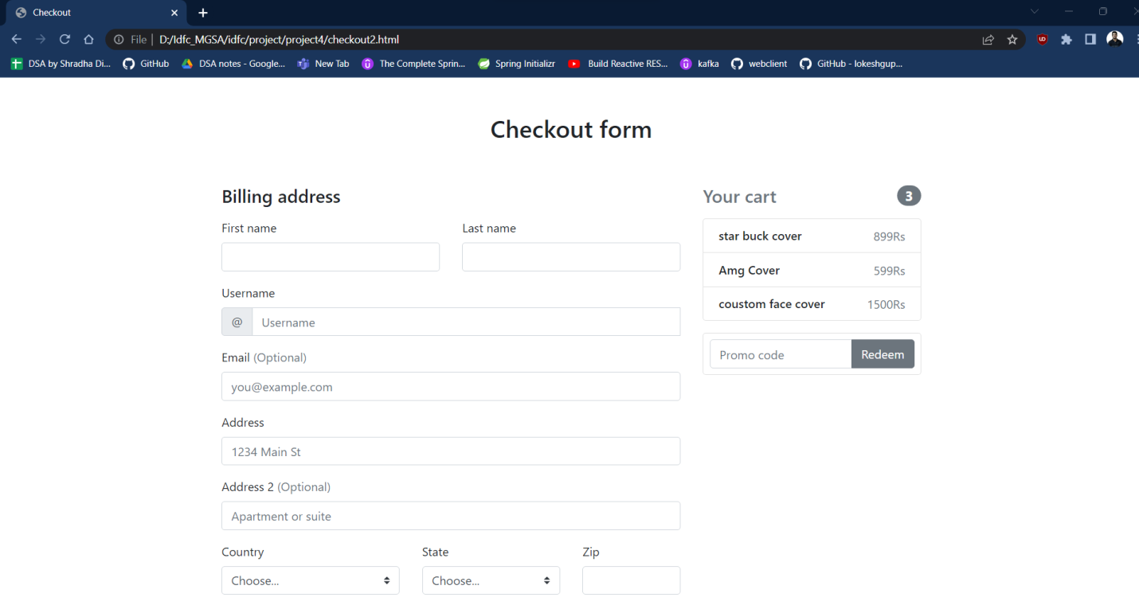

**About Us Page**

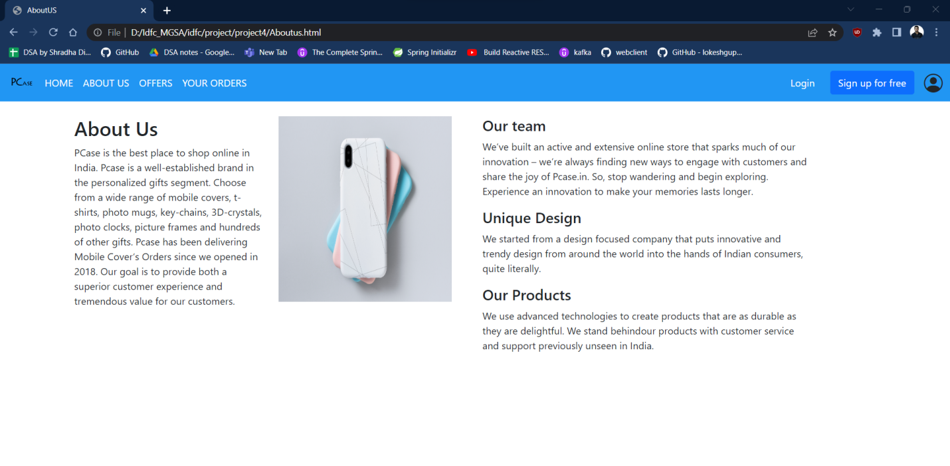

**LogOn**

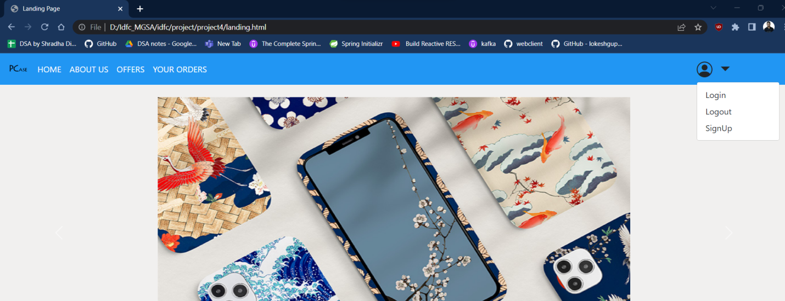

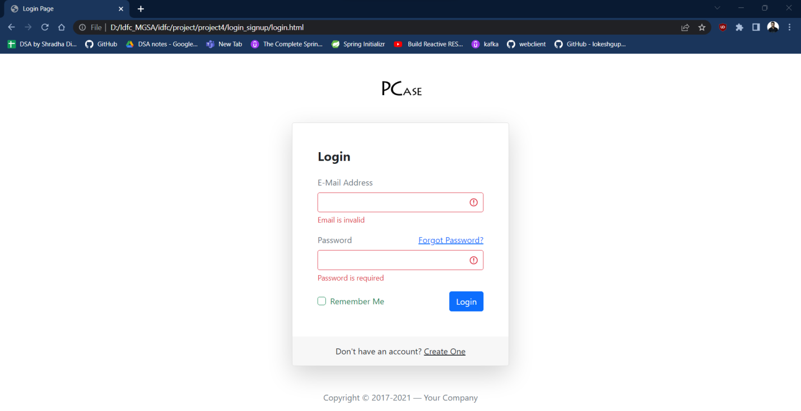

**Still invalid email**

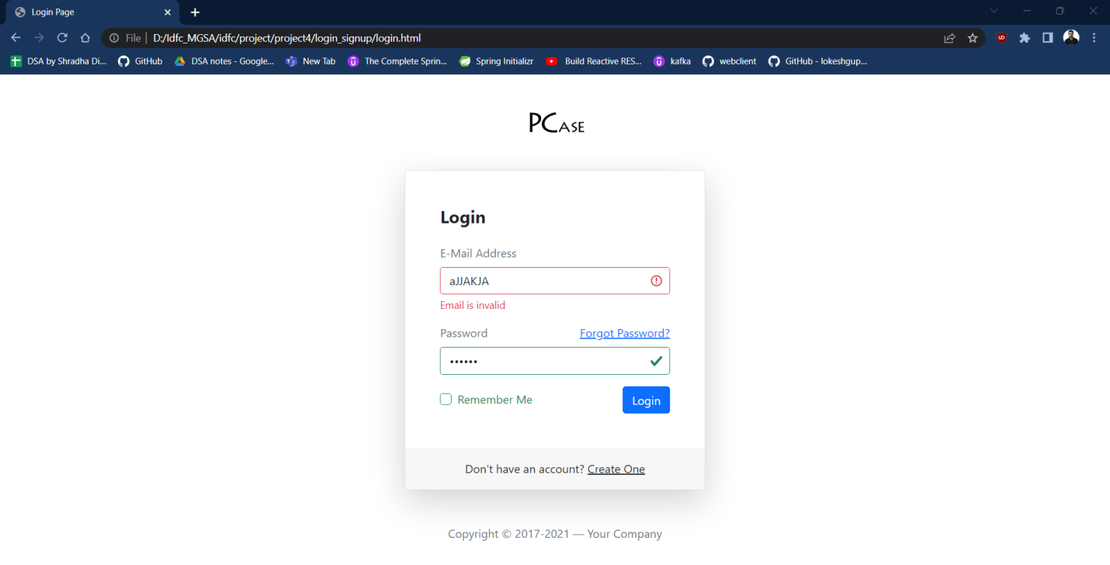

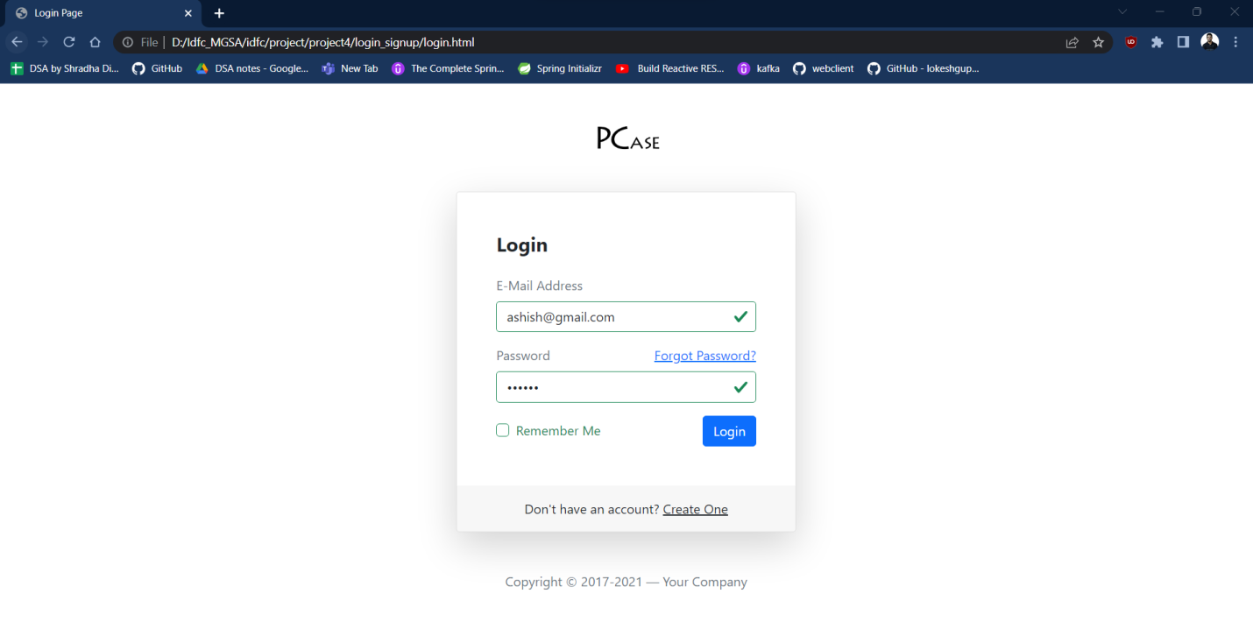

**Register**

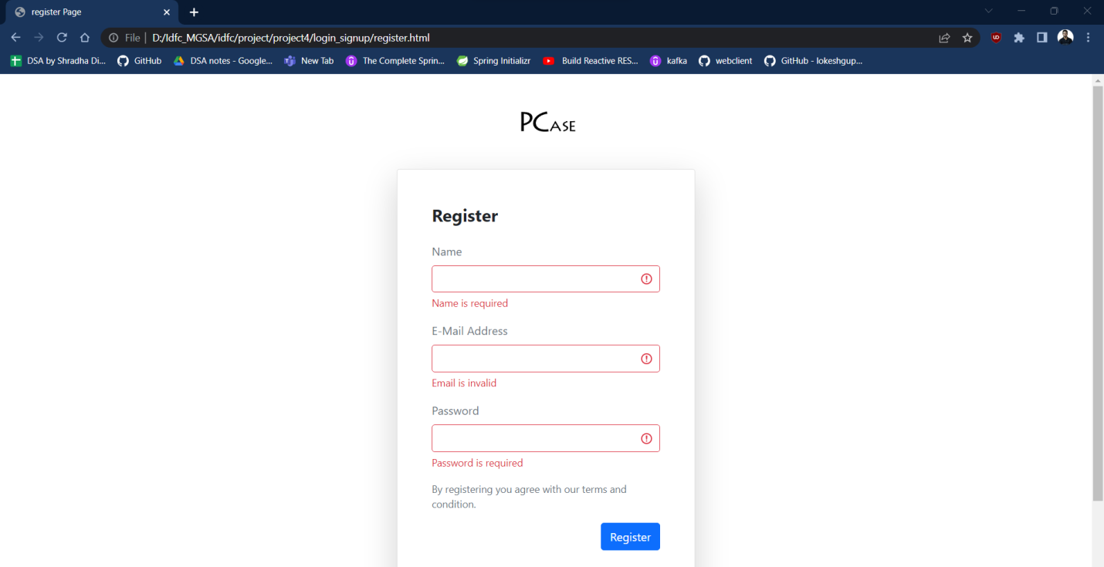

**Forgot**

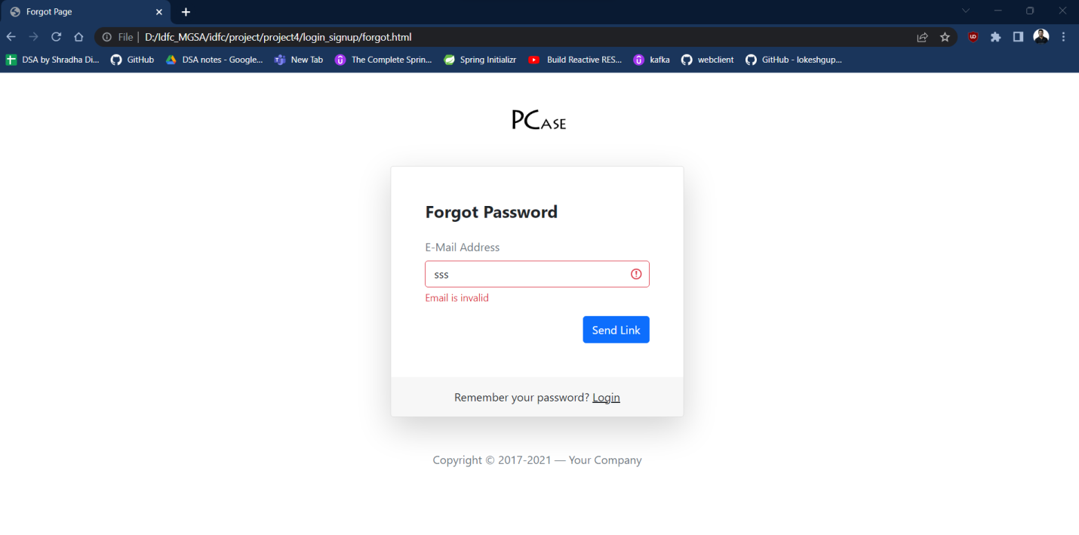

**Offer Page**

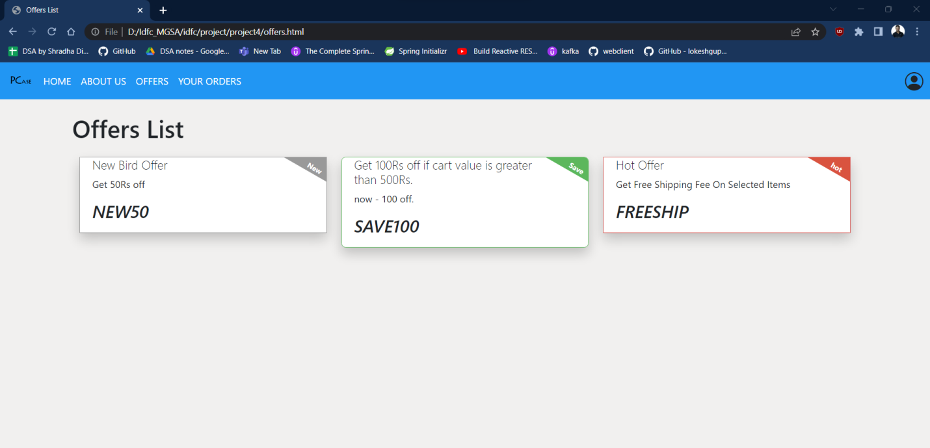

**NEW 50 Coupon**

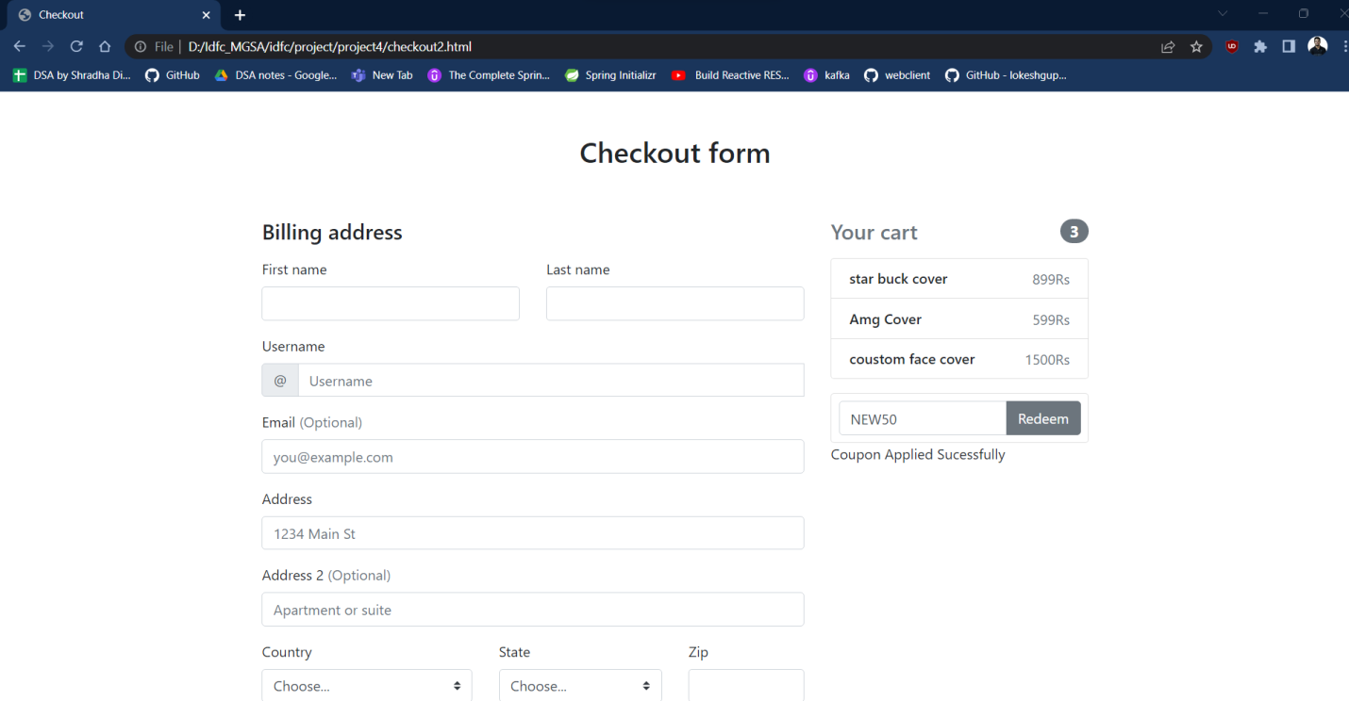

**Wrong Code**

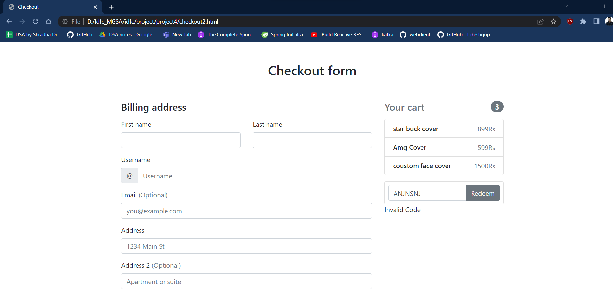

**FOR SAVE 100 Coupon**

1. **Cart value less than Rs500**

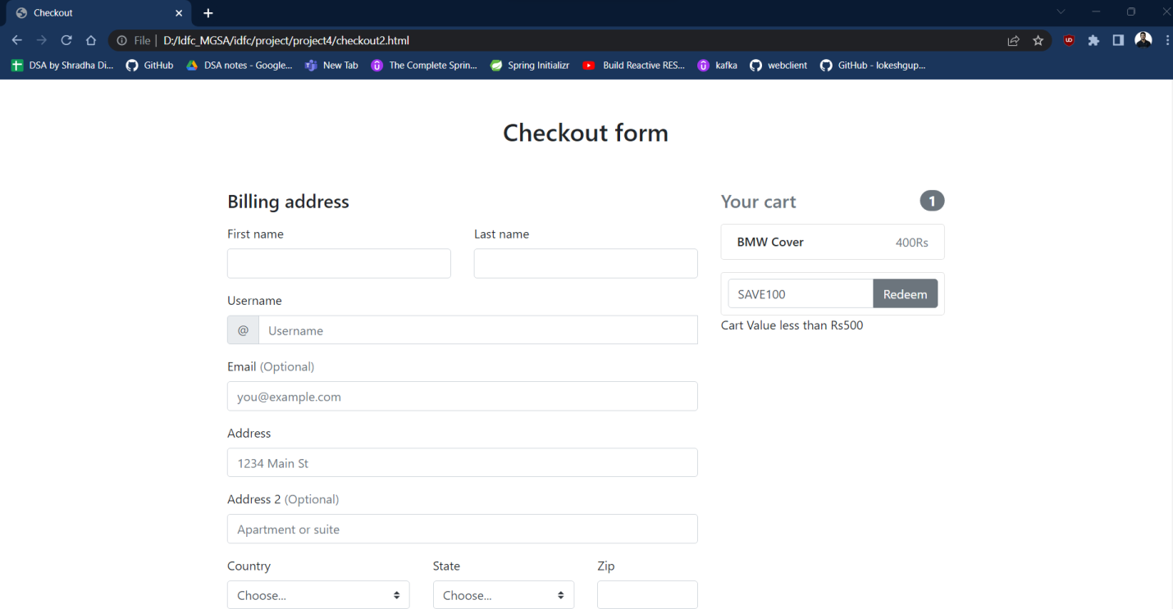

**B. Cart value greater than Rs500**

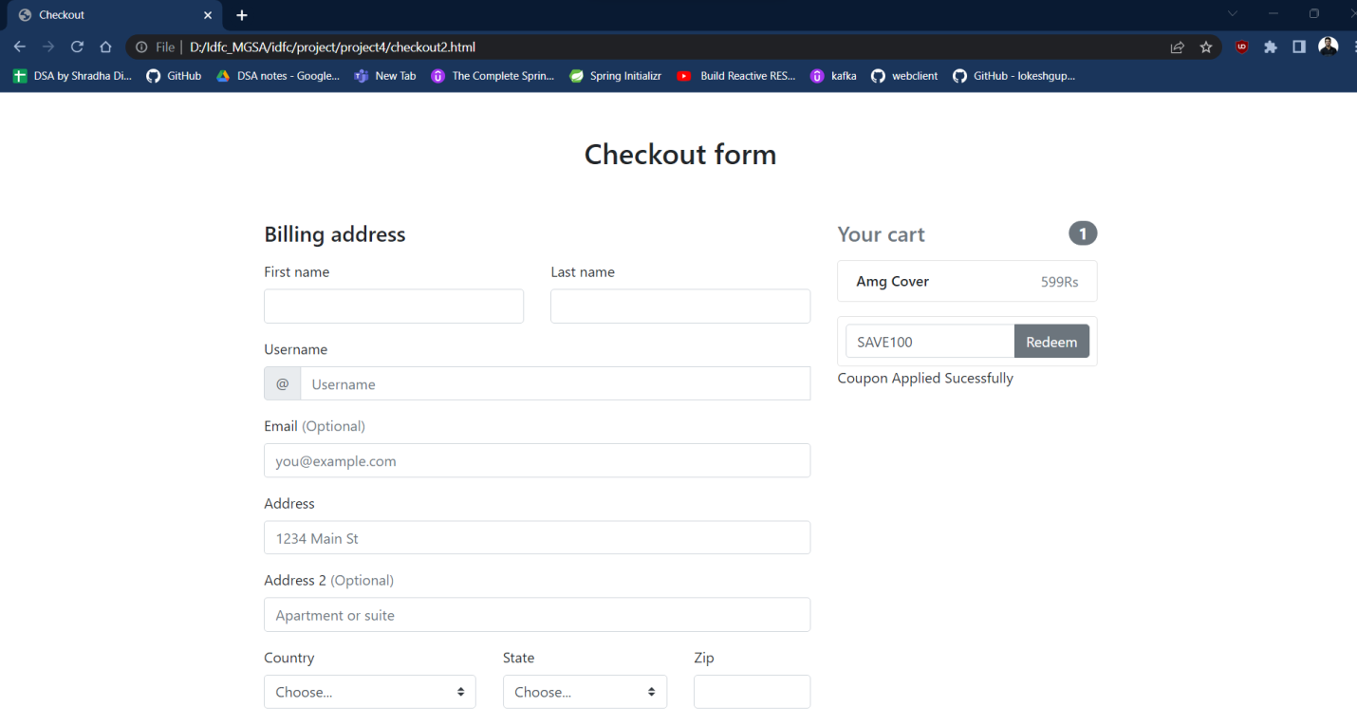

**FREESHIP COUPON ON SALE ITEMS**

**If not a sale item**

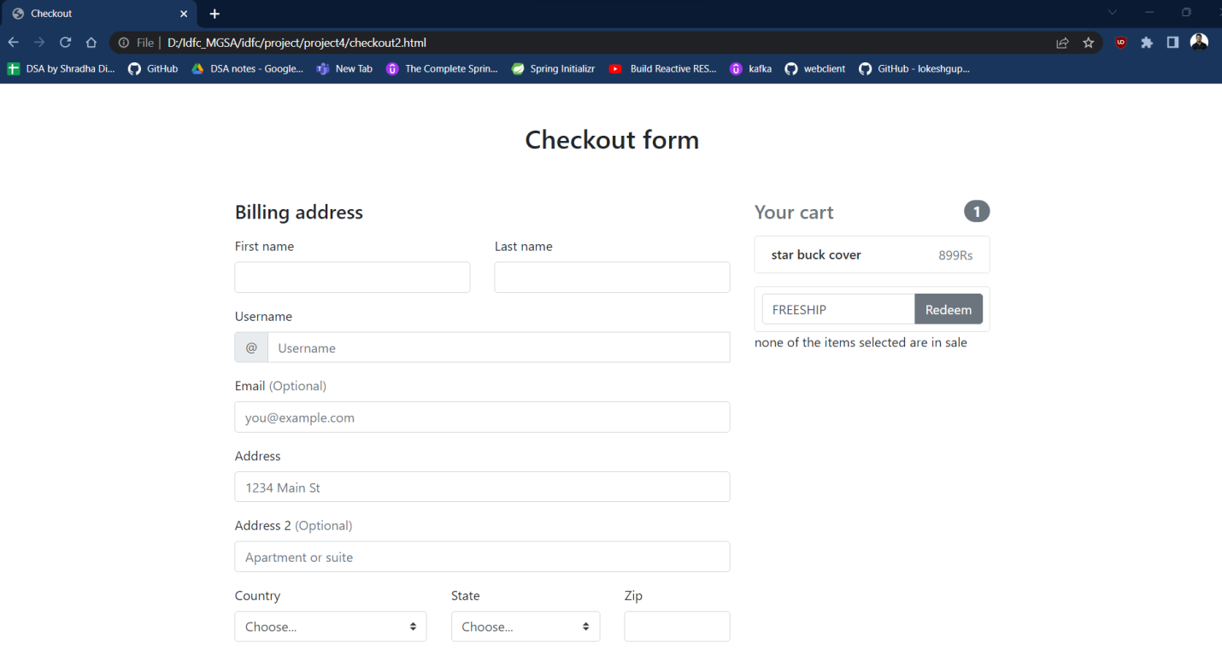

**IF ITEMS SELECTED ARE IN SALE**

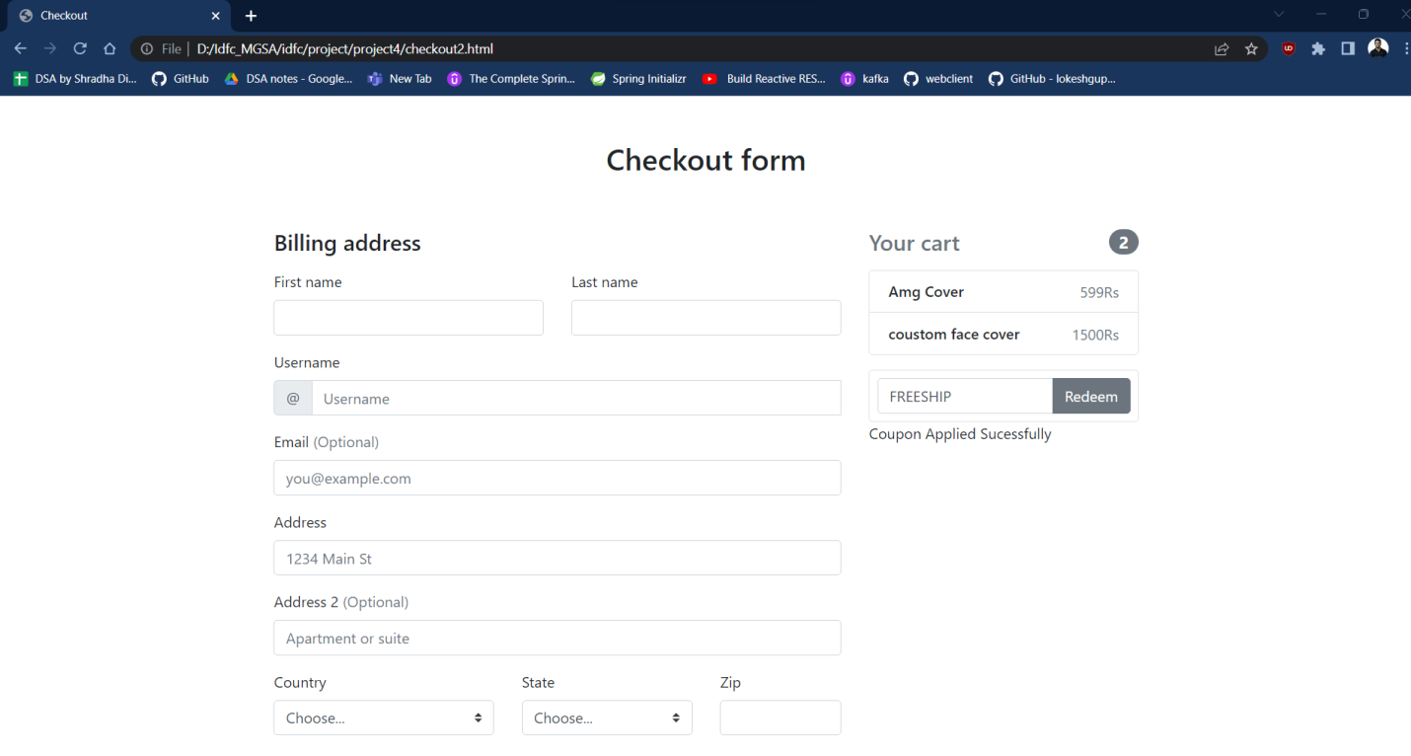

**Checkout Validations**

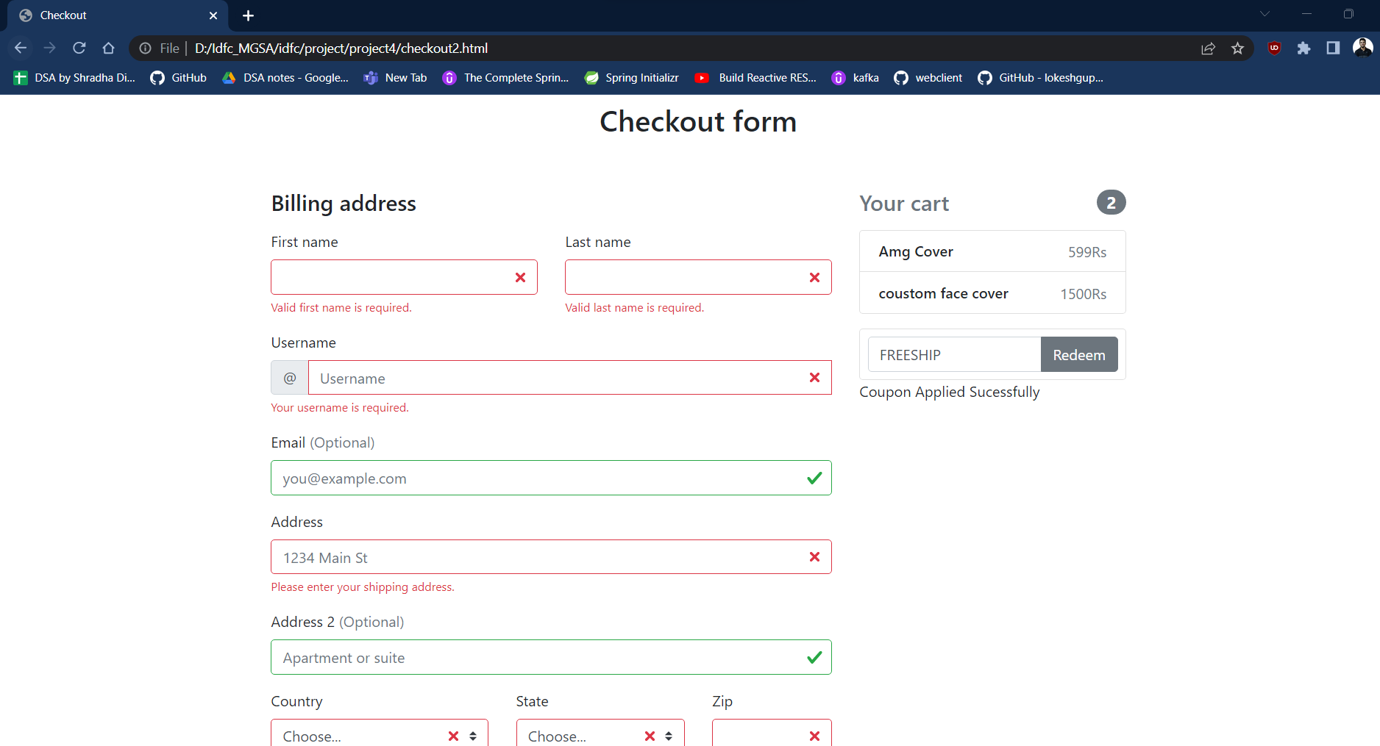

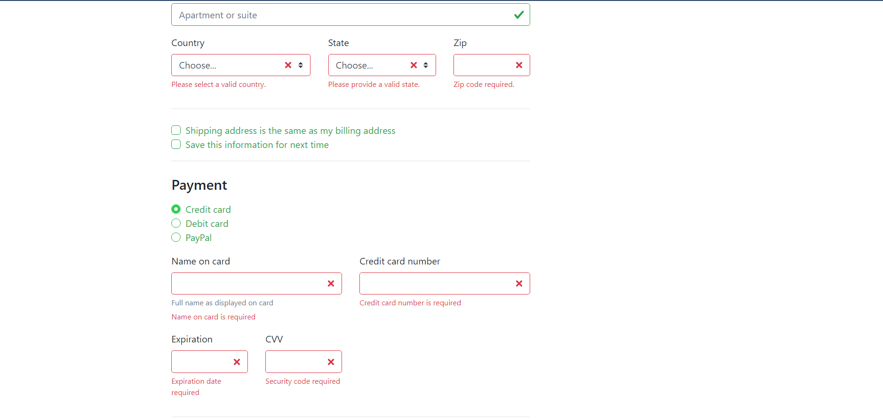

**Filling the correct information**

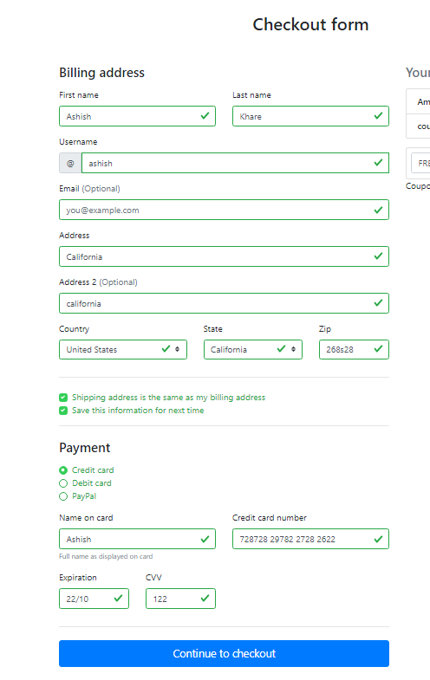

**After Checkout**

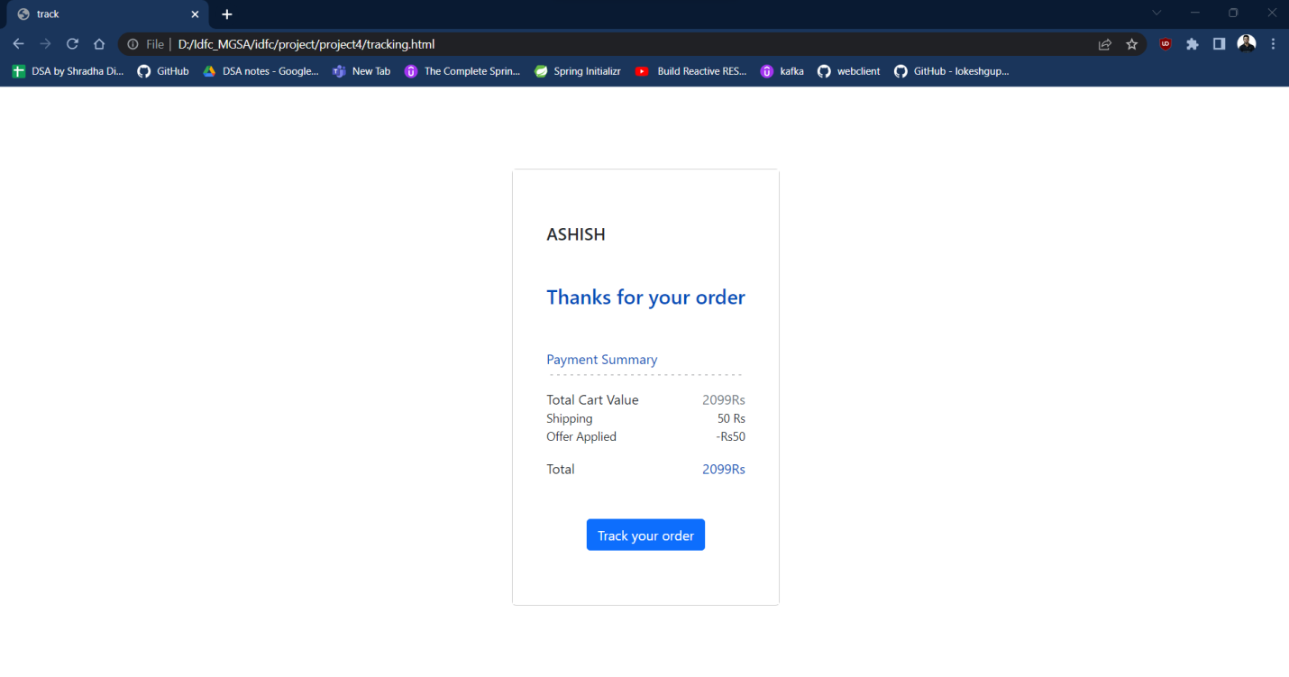

**Contact form with validations**

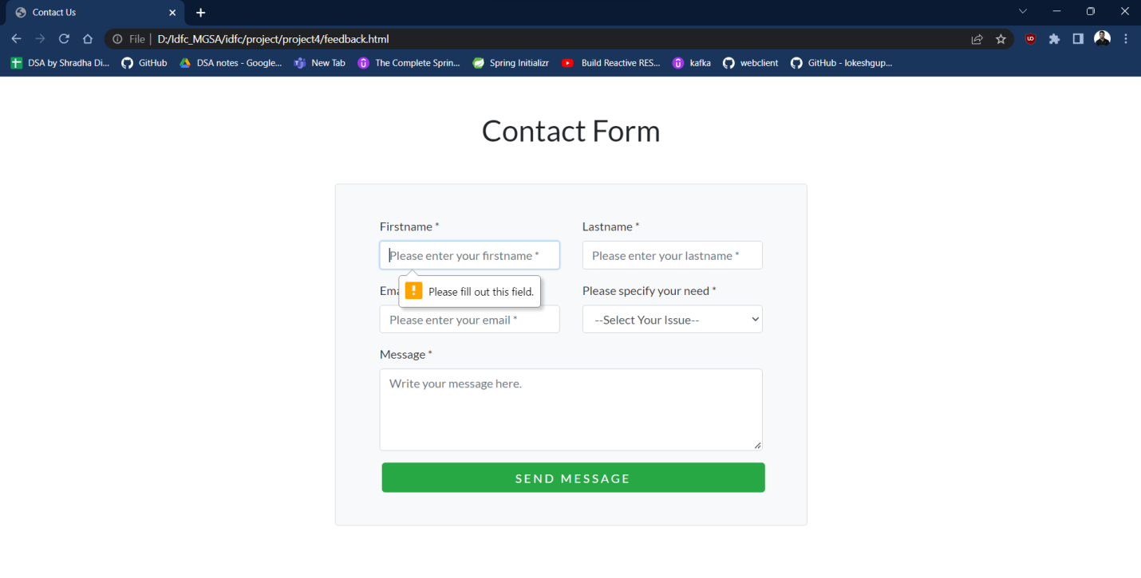

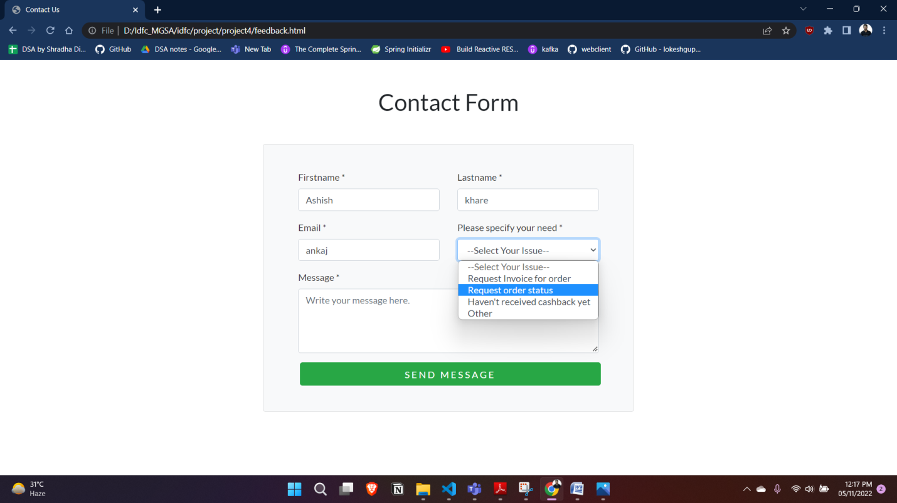

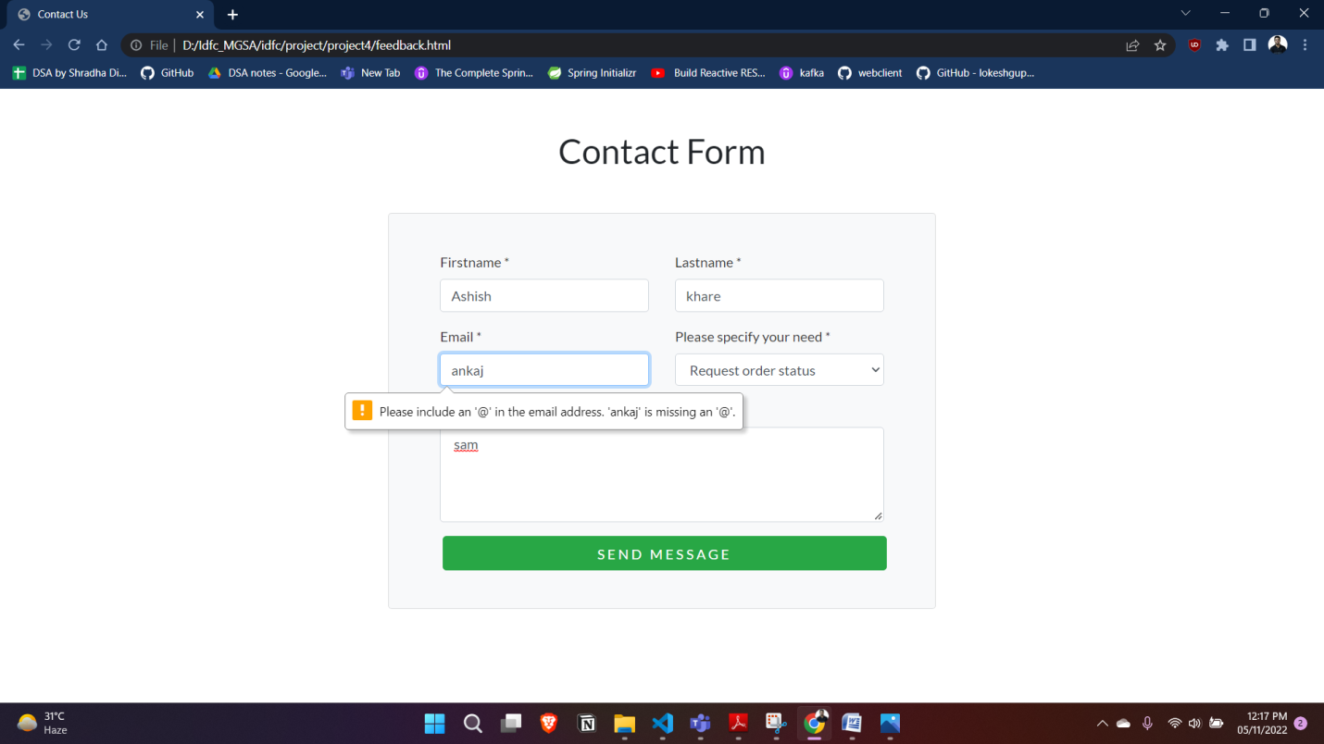

**Conclusion**

In this project I used many new front end technologies like html , css , bootstrap , javascrip , Javascript Dom . Also the project became very useful for me for learning new things by doing practical . Also I learned to create website for two different purpose and that experience was helpful for me and to enhance my knowledge about new emerging technologies.